Analysis Specifications

ID Number: | Version 1
Analysis Name: | Exposure Panel Analysis
Engine Type /  Engine Version; | SAS 9.2  Excel
Analysis Overview: | The Exposure Analysis Panel provides the user with an overview of the treatment dosing in the Exposure Dataset. The Exposure Analysis Panel details the time on drug and number of doses taken by treatment arm, descriptive statistics of the treatment arms, the number of subjects in proposed arm compared to actual treatment, and dosing adjustments.
Analysis Description: | The Exposure Analysis Panel contains the five analyses outlined below:  Analysis 1: Percent of Subjects Left on Study Medication by Day of Study Provides a chart trending the percentage of subjects remaining in the study by treatment arm.  Analysis 2: Distribution of Doses by Arm  Provides a chart plotting the percentage of subjects by number of cumulative doses received throughout the study by treatment arm.  Analysis 3: Dose Descriptive Statistics by Arm and Boxplot of Doses  1. Provides a table of the descriptive statistics Mean, Median, Mode, Standard Deviation, Quartile 1, Quartile 3, Minimum, and Maximum for the cumulative doses received by treatment arm.  2. Provides a chart of the descriptive statistics Mean, Median, Standard Deviation, Quartile 1, Quartile 3, Minimum, and Maximum for the cumulative doses received by treatment arm.  Analysis 4: Planned Arm to Actual Treatment Comparison  Provides a table comparing the number of subjects in the planned arm variable from the Demographic Dataset to the number of subjects in the actual treatment variable from the Exposure Dataset.  Analysis 5: Dose Changes During the Study  Provides a table listing the subjects who experienced an adjustment in dose, the dose value and units, and study day the change occurred.
Precondition(s): | The Exposure Analysis Panel has the following preconditions:  - An Exposure Dataset (EX) has to exist according to CDISC SDTM format.  - The Exposure USUBJID and EXSTDTC or EXENDTC must be present  - EXTRT, EXDOSE, EXDOSU, EXDOSFRQ are optional in the EX Dataset  - The Demographic dataset (DM) has to exist according to CDISC SDTM format.  - The Demographic variables ACTARM or ARM, RFSTDTC, and USUBJID must be present in the DM dataset  - ARMCD is option in the DM dataset
Panel Options: | There are no panel options for this analysis.
Input(s): | The Exposure Analysis Panel uses the following data and variables  - Dataset EX –  - EXTRT  - EXDOSE  - EXDOSU  - EXDOSFRQ  - EXSTDTC  - EXENDTC  - USUBJID  - Dataset DM –  - ACTARM  - ARM  - RFSTDTC  - ARMCD  - USUBJID
Input from: | The datasets required to perform the Exposure Analysis Panel are provided by the Script Launcher
Process Flow: | Analysis 1: Percent of Subjects Left on Study Medication  EX  USUBJID  Percent of Subjects by Treatment Group  Output Chart to Excel  ACTARM  RFSTDTC/ EXENDTC  Increasing Chronological Number of Days in the Study  Use DM Dataset to determine the arm variable to get treatment group for each subject  DM  Use DM Dataset to determine the arm variable to get treatment group for each subject  Analysis 2: Distribution of Doses by Arm  DM  USUBJID  Percent of Subjects by Treatment Group  Output Chart to Excel  ACTARM  RFSTDTC/ EXENDTC  Number of Total Doses Taken by Each Subject  EX  EXDOSFRQ  Dose Freq. Ref Dataset  Analysis 3: Dose Descriptive Statistics  DM  Percent of Subjects by Treatment Group  Calculate Descriptive Statistics and Box-Whisker Plots  Final Output to Excel  ACTARM  Number of Total Doses Taken by Each Subject  EX  EXDOSFRQ  RFSTDTC/ EXENDTC  Use DM Dataset to determine the arm variable to get treatment group for each subject  USUBJID  Dose Freq. Ref Dataset  Analysis 4: Planned Arm to Actual Treatment Comparison  DM  Output Chart to Excel  EXTRT  ARM  Count of Subjects in each scheduled treatment group  EX  Count of Subjects in each actual treatment group  Compare Counts of Subjects in actual treatment group with scheduled treatment group  EXDOSU  EXDOSE  Analysis 5: Does Changes during the Study  Output Chart to Excel  EXTRT  EX  List of Subjects who have a change in any variable  USUBJID  EXDOSE  EXDOSU
Study Design: | The Exposure Analysis Panel can be run on studies that are parallel designs and only a single medication is given at a visit.
Requirements: | The Exposure Analysis Panel will perform and execute the following steps in the prescribed order:  Data Pre-processing:  - Identify the Exposure and Demographic Datasets.  - Determine whether the Exposure and Demographics Datasets are in the prescribed CDISC SDTM format and whether the variables within the Dataset comply with CDISC SDTM standards.  - Exposure Dataset EX  - Demographics Dataset DM  - Determine whether the needed Exposure variables are present within the Exposure dataset. These necessary variables include:  - USUBJID  - EXSTDTC or EXENDTC  - Optional variables for EX are:  - EXTRT  - EXDOSE  - EXDOSU  - EXDOSFRQ  - Determine whether the needed Demographic variables are present within the Demographics Dataset.  - ACTARM or ARM  - RFSTDTC  - USUBJID  - Optional variables for DM are:  - ARMCD  - If the Exposure and Demographic Datasets and variables are CDISC compliant and the required variables are all present, continue  - Merge the Exposure and Demographics Datasets by USUBJID and keep observations that have an USUBJID in both datasets.  - If ARMCD is equal “SCRNFAIL” or “NOTASSGN” then delete  Analysis 1: Percent of Subjects Left on Study Medication by Day of Study  - Provides a chart showing the percentage of subjects remaining in each arm on each day of the study. Percentages are calculated by using the number of remaining subjects assigned to a drug as the numerator and the total count of subjects who have been assigned to a drug as the denominator.  - The denominator is based on the total number of subjects in the DM Dataset that have been assigned to a treatment group in the ACTARM variable if available, ARM variable otherwise.  Figure 1:  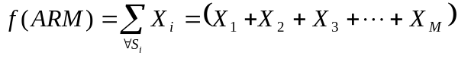  where  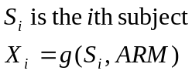  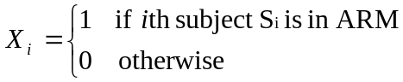  - Calculate study days using the following conditions:  - If EXENDTC is not missing then use EXENDTC to calculate study day  - If EXENDTC is on or after RFSTDTC then EXENDY= (date portion of EXENDTC) - (date portion of RFSTDTC) + 1  - If EXENDTC precedes RFSTDTC then EXENDY = (date portion of RFSTDTC) - (date portion of EXENDTC) +1  - Otherwise use EXSTDTC to calculate study day  - If EXSTDTC is on or after RFSTDTC then EXENDY= (date portion of EXSTDTC) - (date portion of RFSTDTC) + 1  - If EXSTDTC precedes RFSTDTC then EXENDY = (date portion of RFSTDTC) - (date portion of EXSTDTC) +1  - Use the last study day (EXENDY) for each USUBJID to calculate how many subjects were present in the study through time.  - E.g. If last EXENDY = 100 then that USUBJID would be considered present in the study from day 1 to 100.  - By treatment, calculate the percent of USUBJIDs remaining on each day of the study through the last day.  - The outputs produced in Analysis 1 will be exported into an Excel workbook and used in a XY scatterplot with data points connected by lines without markers, defined as:  - By treatment, plot the percentage of subjects on the y-axis and study days on the x-axis.  Analysis 2: Distribution of Doses by Arm  - Provides a chart showing the distribution of doses among each arm’s subjects in terms of a percentage of the maximum total number of doses received throughout the study in each treatment arm.  - Determine the study day of each exposure event  - If EXENDTC is not missing then use EXENDTC to calculate study day  - If EXENDTC is on or after RFSTDTC then EXENDY= (date portion of EXENDTC) - (date portion of RFSTDTC) + 1  - If EXENDTC precedes RFSTDTC then EXENDY = (date portion of RFSTDTC) - (date portion of EXENDTC) +1  - Otherwise use EXSTDTC to calculate study day  - If EXSTDTC is on or after RFSTDTC then EXENDY= (date portion of EXSTDTC) - (date portion of RFSTDTC) + 1  - If EXSTDTC precedes RFSTDTC then EXENDY = (date portion of RFSTDTC) - (date portion of EXSTDTC) +1  - Determine the number of study days since the subject’s prior exposure event by subtracting the study day from the prior study day; if the exposure event is the subject’s first, the number of study days is the study day  - Determine the number of doses taken for each exposure event by multiplying the dosing frequency, stored as a code in the EXDOSFRQ variable, by the number of study days since the prior exposure event  - EXDOSFRQ variable. This variable is a character variable using the Latin medical abbreviations.  - Dose frequencies corresponding to EXDOSFRQ codes are taken from a lookup table made from the SDTM Terminology (2010-10-06) (See appendix B)  - If the dose frequency is not found, assume 1 dose per study day.  - If the dose form, EXDOSFRM, contains ‘INJECTION’, assume one dose per exposure event.  - Otherwise, multiply dose frequency by the number of study days since the prior study day to find the number of doses taken for each exposure event  - Find the total number of doses taken by each subject by adding up the doses taken at each of a subject’s exposure events  - The outputs produced in Analysis B will be exported into and Excel and/or Word document and defined as:  - Plot the percentage of subjects in each range on the Y-Axis and dose ranges on the X-Axis.  Analysis 3: Dose Descriptive Statistics and Boxplot of Doses by Arm  - Produces descriptive statistics for the cumulative number of doses taken by arm. The number of treatments a subject receives is calculated using the same logic as Analysis 2.  - N is based on the total number of subjects in the DM Dataset that have been assigned to a treatment group in the ACTARM variable if available, ARM variable otherwise.  - Mean (Formula depicted in Figure 2)  Figure 2  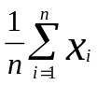  i represents the index summation  n is the upper bound of the summation  x is the variable of interest  - Median  The middle value of the given numbers or distribution in their  ascending order  - Mode  The most frequently occurring value in a frequency distribution.  - Standard Deviation  Figure 3  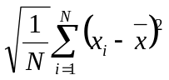  i represents the index summation  x is the variable of interest  N is the upper bound of the summation, i.e. the number of subjects exposed to at least one dose of treatment  1st Quartile (25th Percentile)  Figure 4  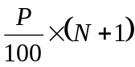  P is the desired percentile  N is the number of numbers  - 3rd Quartile (75th Percentile, Formula depicted in Figure 4)  - Minimum  The smallest value for each treatment arm  - Maximum  The largest value for each treatment arm  - The outputs produced in Analysis 3 will be exported into Excel and defined as:  - A table will list all of the statistics produced in Analysis 3 Section 1  - A Box and Whisker Plot will graph the statistics produced in Analysis 3 Section 1.  - Total number of doses taken on the y-axis  - Treatment arms on the x-axis  Analysis 4: Planned Arm to Actual Treatment Comparison  - Shows side-by-side the number of subjects in the planned treatment groups compared to the actual treatment received from exposure.  - Calculate the number of subjects in the planned treatment group using the planned arm variable ARM for each subject.  - Calculate the number of subjects in the actual treatment group using a combined EXTRT/EXDOSE/EXDOSU variable for each ARM.  - The output produced in Analysis 4 will be exported into an Excel document and defined as:  - Planned Treatment Arm (ARM variable), Actual Treatment Received (combined EXTRT/EXDOSE/EXDOSU variable) and Count will be the Titles in the table.  Analysis 5: Dose Changes During the Study  - Lists each change in dose experience by a subject.  - Using the EXTRT, EXDOSE, and EXDOSU variables identify all cases that had a dose adjustment.  - The outputs produced in Analysis E will be exported into an Excel document and defined as:  - Subject (USUBJID variable), Original Dose (combined EXTRT/EXDOSE/EXDOSU variables), New Dose (combined EXTRT/EXDOSE/EXDOSU variables),and Date of Change (EXENDTC variable), calculated study day, and reason for adjustment (EXADJ)  - If no reason for adjustment exists, use ‘Not Given’

Screenshots: | Analysis 1: Total Number of Days of Drug  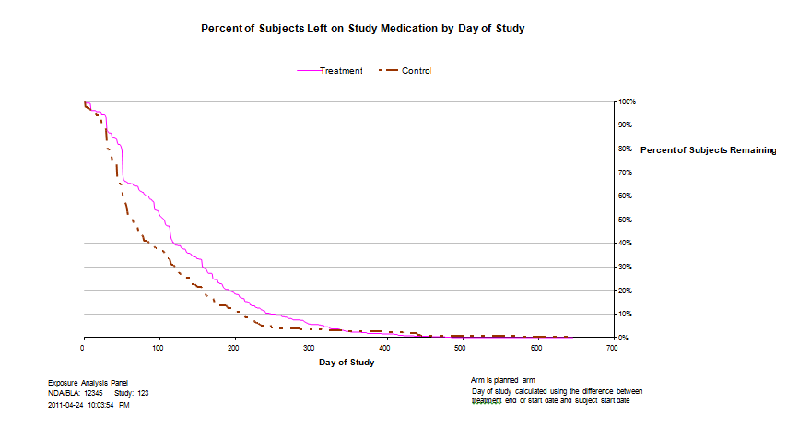  Analysis 2: Cumulative Dose  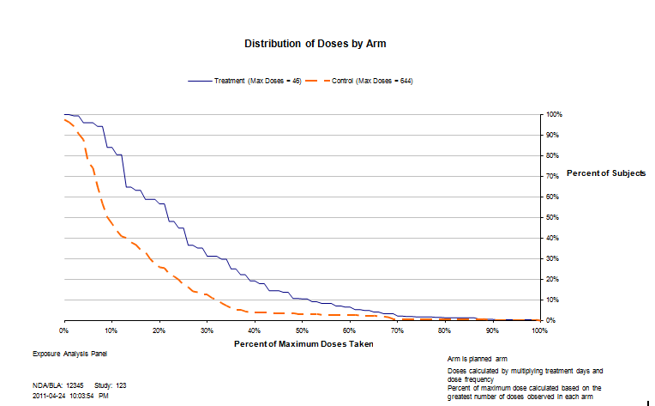  Analysis 3: Dose Descriptive Statistics and Boxplot of Doses by Arm  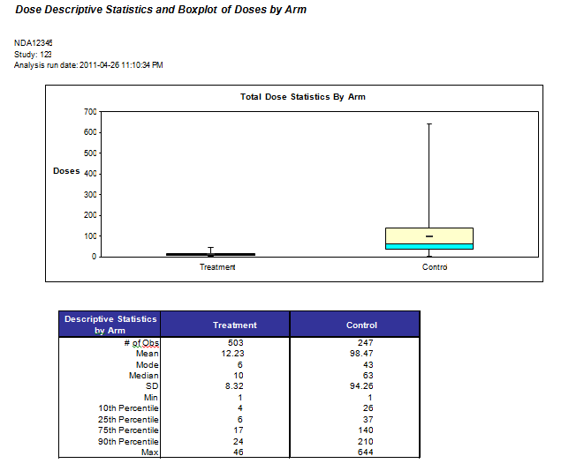  Analysis 4: Count of Subjects by Treatment Arm and Actual Treatment  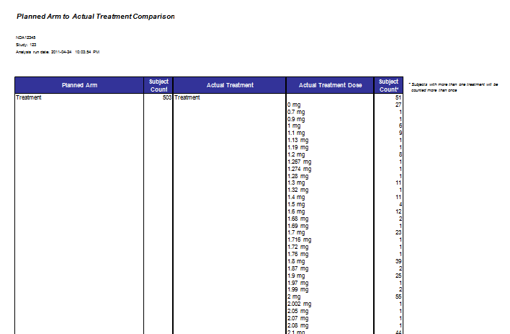  Analysis 5: Dose Changes During the Study  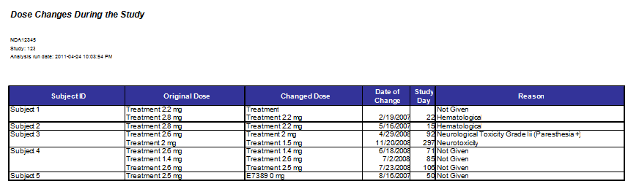
Data Checks: | - Keep counts per arm of the number of subjects who were removed from analysis because either the panel could not determine a study day for any of their exposure events or the subject was a screen failure or unassigned.  - Keep counts per arm of the number of number of exposure events removed from analysis because the number of doses could not be determined and the number of subject affected  - Keep counts per arm and dose form (EXDOSFRM) of the number of missing dose frequencies (EXDOSFRQ)
Assumptions: | The Exposure Analysis Panel assumes:  - The User has access to the following CDISC SDTM datasets: Exposure (EX) and Demographic (DM).  - The analysis will not be run on cross over studies.
Notes and Issues: | Limitations:  - The Exposure Analysis Panel currently uses the Planned Arm in the Demographics Dataset if Actual Arm (ACTARM) is not available to determine which treatment arm a subject has been exposed to. This is not entirely accurate since the subject might not have been assigned to the arm that he or she was originally planned for.  - At the moment there is no consistent automatic method to build a flag to determine the Actual Arm a subject has been put into, since the terms needed vary greatly across submissions, unless ACTARM is available  - The Analysis is limited by the dose information provided in the Exposure Dataset. This Dataset does not note if a participant skips a particular dose.  - Due to the structure of the data being one treatment and dose per visit, cross-over study analysis can not be performed with the Exposure panel programs
Approval /  Validation Status: | Status Pending and Validation Required
Created By: | Ingeborg Holt | Last Updated By: | David Kretch
Date Created: | 01/12/10 | Date Last Updated: | 04/26/2011

Appendix A
Source Code:
/****************************************************************************/
/* PROGRAM NAME: Exposure Analysis Panel */
/* */
/* DESCRIPTION: Does an analysis of the exposure events for */
/* subjects in the study */
/* */
/* EVALUATION TYPE: Safety */
/* */
/* AUTHOR: Andreas Anastassopoulos */
/* (andreas.anastassapoulos@us.ibm.com) */
/* */
/* DATE: March 16, 2010 */
/* */
/* EXTERNAL FILES USED: Exposure_Template.xls -- Excel template */
/* data_checks_exposure.sas -- EX data checks */
/* exposure_exdosfrq.csv -- dose frequency codes */
/* data_checks.sas -- Generic variable checks */
/* sl_gs_output.sas -- Script Launcher settings output*/
/* err_output.sas -- Error output when missing vars */
/* */
/* PARAMETERS REQUIRED: saspath -- location of external panel SAS programs */
/* utilpath -- location of external util SAS programs */
/* dosfrqpath -- location of the EXDOSFRQ code list */
/* ndabla -- NDA or BLA number */
/* studyid -- study number */
/* */
/* studypath -- location of the drug study datasets */
/* outpath -- location of the output */
/* outfile -- filename of the output */
/* templatepath -- location of the Excel template */
/* template -- filename of the template */
/* */
/* VARIABLES REQUIRED: DM -- ACTARM or ARM */
/* RFSTDTC */
/* USUBJID */
/* EX -- USUBJID */
/* EXENDTC or EXSTDTC */
/* */
/* OTHER VARIABLES USED: DM -- ARMCD */
/* IF AVAILABLE EX -- EXTRT */
/* EXDOSE */
/* EXDOSU */
/* EXDOSFRQ */
/* EXDOSFRM */
/* EXADJ */
/* */
/* MADE WITH: SAS 9.2 */
/* */
/* NOTES: */
/* */
/****************************************************************************/

/* REVISIONS */
/*
** 8/10 changes includes adding the study day and the reason to dose changes ***;
** 8/11 changes include making cummulative dose graph as percent of total doses instead of number **;
** 8/16 changes the cummulative dose to make it a continuous graph ***;
** 8/18 changes the SCHEDULED vs ACTUAL **;
** 8/24 changes the verbiage of the ARM in dose graph ***;

2011-02-29 DK Added exposure dose frequency lookup
Changed template and output method

2011-03-05 DK Added grouping & subsetting output

2011-03-27 DK Added run location handling

2011-04-26 DK Fixed planned arm in planned arm vs actual arm when ACTARM is present

2011-05-08 DK Error/no subjects in DM handling

2011-06-09 DK Fixed a bug where the hash table in the EX_DM merge would fail to initialize
because the first observation was not a match by adding a count of matches
*/

/* the minoperator option allows the use of the in operator by the macro language */
options minoperator;
options missing='';

/* determine the run location by looking for the SL-set run_location macro variable */
%sysfunc(ifc(not %symexist(run_location),%nrstr(%let run_location = local;),));
%put RUN LOCATION: &run_location.;

%macro params;

/* program parameters if the program is run locally */
%if %upcase(&run_location.) = LOCAL %then %do;

data macrovar; set sashelp.vmacro(keep=scope name where=(scope='GLOBAL' & name ne 'RUN_LOCATION')); run;
data _null_; set macrovar; call execute('%symdel '||trim(left(name))||';'); run;
proc datasets kill; quit;

%global panel_title panel_desc;
%let panel_title = Exposure;
%let panel_desc = ;

/* NDA/BLA number */
/* study number */
%global ndabla studyid;
%let ndabla = 12345;
%let studyid = 123;

/* location of the study being examined */
%let studypath = C:\Documents and Settings\MATTOK\Desktop\Data\NDA12345;

libname path "&studypath.";

/* retrieve datasets */
data dm; set path.dm; run;
data ex; set path.ex; run;

/* location of external SAS programs */
%global saspath utilpath;
%let saspath = C:\Documents and Settings\MATTOK\Desktop\SL_SAS_Progs\ExposureGeneral;
%let utilpath = C:\Documents and Settings\MATTOK\Desktop\SL_SAS_Progs\ZZ_Utilities;

/* read in the list of dose frequencies from the CSV file */
%global dosfrqpath;
%let dosfrqpath = C:\Documents and Settings\MATTOK\Desktop\SL_SAS_Progs\ExposureGeneral;

/* location and filename of the disposition panel template */
%let templatepath = C:\Documents and Settings\MATTOK\Desktop\SL_Templates\ExposureGeneral;
%let template = Exposure_Template.xls;

/* location and filename of the output */
%let outpath = C:\Documents and Settings\MATTOK\Desktop\Output;
%let outfile = Exposure.xls;

%global expout errout;
%let expout = &outpath.\&outfile.;
%let errout = &outpath.\Exposure Error Summary.xls;

options noxwait xsync;

/* copy the template to the output file */
x "%str(copy %"&templatepath.\&template.%" %"&expout.%")";

/* dummy grouping, subsetting, and dataset information datasets */
data sl_datasets;
datatype = ''; name = ''; partition_variable = ''; default = '';
delete;
run;
data sl_group;
group_name = ''; domain = ''; partition = ''; var_name = ''; var_value = ''; dsvg_grp_name = '';
delete;
run;
data sl_subset;
name = ''; domain = ''; partition = ''; var_name = ''; var_value = ''; inner_operator = ''; outer_operator = '';
delete;
run;

%end;

/* program parameters if the program is run through Script Launcher */
%else %do;

%global dosfrqpath;
%let dosfrqpath = &saspath.;

/* map the user-defined Script Launcher panel option values onto panel macro variables */
data _null_;
run;

%end;

%mend params;

%params;

%include "&saspath.\data_checks_exposure.sas";
%include "&utilpath.\data_checks.sas";
%include "&utilpath.\sl_gs_output.sas";
%include "&utilpath.\err_output.sas";

/***************************************/
/* REQUIRED & OPTIONAL VARIABLE CHECKS */
/***************************************/
%macro ex_prelim_check;

/* check whether there are subjects in DM */
%chk_dm_subj_gt0;

/* required */
%chk_var(ds=dm,var=rfstdtc);
%chk_var(ds=dm,var=usubjid);
%chk_var(ds=ex,var=usubjid);

data rpt_chk_var_req; set rpt_chk_var; run;

/* actual arm or planned arm */
%chk_var(ds=dm,var=actarm);
%chk_var(ds=dm,var=arm);

/* insert a row into RPT_CHK_VAR_REQ indicating whether actual arm OR arm exists */
proc sql noprint;
insert into rpt_chk_var_req
set chk = 'VAR',
ds = 'DM',
var = 'ACTARM or ARM',
condition = 'EXISTS',
ind = %sysfunc(ifc(&dm_actarm. or &dm_arm.,1,0));
quit;

%chk_var(ds=ex,var=exendtc);
%chk_var(ds=ex,var=exstdtc);

%let ex_exdt = %sysfunc(ifc(&ex_exendtc. or &ex_exstdtc.,1,0));

proc sql noprint;
insert into rpt_chk_var_req
set chk = 'VAR',
ds = 'EX',
var = 'EXSTDTC or EXENDTC',
condition = 'EXISTS',
ind = &ex_exdt.;
quit;

%global all_req_var;
proc sql noprint;
select (case when count = 0 then 1 else 0 end) into: all_req_var
from (select count(1) as count
from rpt_chk_var_req
where ind ne 1);
quit;

/* optional */
%chk_var(ds=dm,var=actarm);
%chk_var(ds=dm,var=armcd);
%chk_var(ds=ex,var=exdosfrm);
%chk_var(ds=ex,var=exdosfrq);
%chk_var(ds=ex,var=extrt);
%chk_var(ds=ex,var=exdose);
%chk_var(ds=ex,var=exdosu);
%chk_var(ds=ex,var=exadj);

%mend ex_prelim_check;

/*****************/
/* preprocessing */
/*****************/
%macro ex_setup;

%put *******************************************;
%put * EXPOSURE ANALYSIS DATASET PREPROCESSING *;
%put *******************************************;

/* valid EXDOSFRQ values implying a specified number of doses per hour/day/week */
/* taken from SDTM Terminology 10.06.2010 */
data exdosfrq;
infile "&dosfrqpath.\exposure_exdosfrq.csv" dsd delimiter=',' truncover;
length exdosfrq $20 description $50 frequency $10 unit $1;
input exdosfrq $ description $ frequency $ unit $;

index = index(frequency,'/');
if not index then exdosfrqn = input(frequency,8.);
else exdosfrqn = input(substr(frequency,1,index-1),8.) / input(substr(frequency,index+1),8.);
run;

/* store dosing frequency codes in a macro variable */
/* for use in the panel data checks */
%global vld_exdosfrq;
proc sql noprint;
select "'"||trim(exdosfrq)||"'" into: vld_exdosfrq separated by ' '
from exdosfrq;
quit;

/* used ACTARM if it is available */
%if &dm_actarm. %then %do;
proc datasets library=work;
modify dm;
rename %if &dm_arm. %then arm=plannedarm;
actarm=arm;
quit;
%end;

** SORT THE DATASETS AND KEEP THE NEEDED VARIABLES ****;
data dm;
set dm;

%if &dm_armcd. %then %do;
if ARMCD in("SCRNFAIL","NOTASSGN") then delete;
%end;

/* put arm into propcase */
arm_display = arm;
if arm_display ne '' and not anylower(arm_display) then do;
length arm_word $50;
i = 1;
arm_word = scan(arm_display,i);
do while (arm_word ne '');
if length(arm_word) > 3 and not anydigit(compress(arm_word))
then substr(arm_display,index(arm_display,compress(arm_word)),length(compress(arm_word))) =
propcase(compress(arm_word));
if compress(arm_word) in ('MG' 'KG')
then substr(arm_display,index(arm_display,compress(arm_word)),length(compress(arm_word))) =
lowcase(arm_word);
if compress(arm_word) = ('ML')
then substr(arm_display,index(arm_display,compress(arm_word)),length(compress(arm_word))) = 'mL';
i = i + 1;
arm_word = scan(arm_display,i);
end;
end;
arm = arm_display;
drop arm_display arm_word i;
run;

proc sort data = dm(keep = USUBJID RFSTDTC arm %if &dm_actarm. and &dm_arm. %then plannedarm;);
by USUBJID;
run;

data ex;
set ex;
format exendt e8601da.;
format exstdt e8601da.;
call missing(exendt,exstdt);

/* if EXENDTC/EXSTDTC exist, convert them to SAS date format */
/* put missing values at the end at the next sort using the sort order variable */
%if &ex_exendtc. %then %do;
if exendtc ne '' then do;
exendt = input(exendtc,e8601da.);
exendt_sort = 1;
end;
else do;
exendt = .;
exendt_sort = 2;
end;
%end;

%if &ex_exstdtc. %then %do;
if exstdtc ne '' then do;
exstdt = input(exstdtc,e8601da.);
exstdt_sort = 1;
end;
else do;
exstdt = .;
exstdt_sort = 2;
end;
%end;

%if &ex_extrt. %then %do;
extrt = propcase(extrt);
%end;

/* if EXDOSFRQ isn't in the EX dataset, create it and initialize it as missing */
%if not &ex_exdosfrq. %then %do;
length exdosfrq $1;
call missing(exdosfrq);
%end;

/* if EXDOSFRM isn't in the EX dataset, create it and initialize it as missing */
%if not &ex_exdosfrm. %then %do;
length exdosfrm $1;
call missing(exdosfrm);
%end;

run;

%if &ex_exendtc. %then %do;
proc sort data = ex;
by USUBJID exendt_sort exendt;
run;
%end;
%else %if &ex_exstdtc. %then %do;
proc sort data = ex;
by USUBJID exstdt_sort exstdt;
run;
%end;

** MERGE THE EXPOSURE AND PATIENT DATASETS AND DETERMINE STUDY DAYS AND NUMBER OF DOSES ****;

data ex_dm;
merge ex(in=a) dm(in=b);
format studydate treatdate enddate date9.;
by USUBJID;
if a and b;

treatdate = exstdt;
studydate = input(substr(RFSTDTC,1,10), yymmdd10.);
enddate = exendt;

/* CALCULATE THE STUDY DAY OF THE EXPOSURE EVENT */
if enddate = . then do;
if treatdate >= studydate then studydays = (treatdate - studydate)+1;
else studydays = (treatdate - studydate);
end;
else do;
if enddate >= studydate then studydays = (enddate - studydate)+1;
else studydays = (enddate - studydate);
end;
*if studydays > 0;

/* CALCULATE THE PERIOD IN DAYS DURING WHICH THE SUBJECT WAS TAKING DOSES OF THE DRUG */
studydays0 = lag(studydays);
if first.usubjid then dose_days = studydays;
else dose_days = studydays - studydays0;
if not missing(dose_days) and dose_days <= 0 then dose_days = 1;

/* set up a count of matching observations so the hash table lookup is initialized on the first match */
retain match;
if a and b then match = sum(match,1);

/* LOOK UP THE FREQUENCY OF DOSES PER INTERVAL FROM THE REFERENCE TABLE */
if match = 1 then do;
declare hash h(dataset:'exdosfrq');
h.definekey('exdosfrq');
h.definedata('exdosfrqn','unit');
h.definedone();
end;

length exdosfrqn 8. unit $1;
label exdosfrqn='Dosing Frequency Per Interval' unit='Dosing Frequency Unit';
call missing(exdosfrqn,unit);
rc = h.find();
drop rc;

/* if no dose frequency was found, assume one dose per study day */
if exdosfrqn = . then do;
exdosfrqn = 1;
unit = 'd';
end;

/* special case to deal with injections */
/* only one injection per exposure event */
if index(upcase(exdosfrm),'INJECTION') then do;
exdosfrqn = 1;
unit = 'o';
end;

select (unit);
when ('h') dose_days_fu = dose_days * 24;
when ('d') dose_days_fu = dose_days;
when ('w') dose_days_fu = dose_days / 7;
when ('m') dose_days_fu = dose_days / 30.4375;
when ('o') dose_days_fu = 1;
otherwise;
end;

doses = dose_days_fu * exdosfrqn;

run;

%mend ex_setup;

/*****************************************/
/* 1. ANALYSIS A: NUMBER OF DAYS ON DRUG */
/*****************************************/
%macro ex_1;

%put *****************************************;
%put * 1. ANALYSIS A: NUMBER OF DAYS ON DRUG *;
%put *****************************************;

** GET THE LAST OBS BY ID ***;

data ex_dm2;
set ex_dm;
by usubjid;
/* get last nonmissing exposure event */
where studydays ne .;
if last.usubjid then output ex_dm2;
run;

** NUMBER OF PEOPLE EACH DAY ***;
proc summary data = ex_dm2;
class studydays arm;
output out = num_days;
run;

** KEEP THE RIGHT OBS ***;

proc sort data = num_days (where=(_type_ in (1,3)));
by arm studydays;
run;

** FIGURE OUT THE NUMBER OF TREATMENTS **;

proc sort data = num_days nodupkey out = num_treatments;
by arm;
run;

** MAKE THE NUMBER OF TREATMENTS A MACRO **;
%global num_treatments;
proc sql noprint;
select count(*) into: num_treatments
from num_treatments;
quit;

** SET UP A LOOK TO DO ALL OF THE TREATMENTS ***;
%do d = 1 %to &num_treatments;

data treatment;
set num_treatments;
if _N_ = &D;
run;

proc sql noprint;
select arm into: treatment
from treatment;
quit;

** MAX DAYS **;
proc sql noprint;
select max(studydays) into: max_days
from num_days
where arm = "&treatment.";
quit;

** CREATE A DATASET CONTAINING ALL POSSIBLE DAYS ***;
data all_days(drop=I);
do I = 1 to &max_days;
arm = "&treatment.";
studydays = I;
output;
end;
run;

** MERE ALL POSSIBLE DAYS ONTO THE DATASET **;
data num_days&D;
merge num_days all_days;
by arm studydays;
if arm = "&treatment.";
if missing(_freq_) then _freq_ = 0;
run;

data _null_;
treatment2 = compress("&treatment.",'.');
call symput('treatment2',treatment2);
run;

** FIGURE OUT THE NUMBER REMAINING AT EACH DAY OF THE STUDY **;
data num_days&D(keep = studydays ARM_&D);
set num_days&D;
retain total_study left_in_study;

if _type_ = 1 then do;
total_study = _freq_;
left_in_study = _freq_;
studydays = 0;
end;
else left_in_study = sum(left_in_study, - _freq_);
ARM_&D. = left_in_study / total_study;
label arm_&D = "&treatment2."
studydays = 'Day of Study';
studydays = studydays+1;
run;

/* sort for the merge to follow */
proc sort data=num_days&D;
by studydays;
run;

%end;

** MERGE THE DATA BACK TOGETHER TO MAKE ONE SET **;

data final_ExposureA;
merge
%do S = 1 %to &num_treatments;
num_days&S.
%end;
;
by studydays;

if studydays < 1 then delete;

array num{*} _numeric_;
do i = 1 to dim(num);
if num(i) = . then num(i) = 0;
end;
drop i;
run;

%mend ex_1;

/****************************************/
/* 2. ANALYSIS B: DISTRIBUTION OF DOSES */
/****************************************/
%macro ex_2;

%put ****************************************;
%put * 2. ANALYSIS B: DISTRIBUTION OF DOSES *;
%put ****************************************;

** NOW DO THE DOSE BUCKET ANALYSIS ***;

** SUMMARIZE BY ID TO GET THE CUMMULATIVE NUMBER OF DOSES ****;
proc summary data = ex_dm nway;
class usubjid;
id arm;
var doses;
output out = by_usubjid(drop = _type_ _freq_) sum=;
run;

** NOW GET THE MAX DOSES FOR EACH ARM **;

proc sort data = by_usubjid;
by arm decending doses;
run;

data max_doses;
set by_usubjid;
by arm;
if first.arm;
max_doses = doses;
drop usubjid doses;
run;

** MERGE ON ***;

proc sql;
create table by_usubjid2
as select b.*, m.*
from by_usubjid b, max_doses m
where b.arm = m.arm and
b.doses > 0
;
quit;

** DETERMINE THE PECENTS FOR EACH PERSON ***;

data by_usubjid2;
set by_usubjid2;

percent = round(doses/max_doses,.01);
run;

** NUMBER WITH EACH AMOUNT OF DOSE percents ***;

proc summary data = by_usubjid2 nway;
class arm percent;
output out = by_doses(drop=_type_ rename=_freq_=subjects);
run;

** NOW GO AND MAKE SURE ALL PERCENTS FROM 0 to 100 ARE IN THE DATASET FOR EACH ARM ***;

data by_doses2(rename=(subjects2=subjects percent2=percent));
set by_doses;
by arm;
percent0 = lag(percent);
if first.arm then do;
if percent > 0 then do;
do J = 0 to percent-.01 by .01;
percent2 = J;
subjects2 = 0;
output;
end;
percent2 =percent;
subjects2 = subjects;
output;
end;
else do;
percent2 = percent;
subjects2 = subjects;
output;
end;
end;
else do;
if round((percent - percent0),.01) = .01 then do;
percent2 = percent;
subjects2 = subjects;
output;
end;
else do;
do I = percent0 to percent-.01 by .01;
percent2 = I;
subjects2 = 0;
output;
end;
percent2 = percent;
subjects2 = subjects;
output;
end;
end;
drop I j percent0 percent subjects;
run;

proc summary data = by_doses2 nway;
class arm percent;
var subjects;
output out = by_doses2(drop=_type_ _freq_) sum=;
run;

** NUMBER BY EACH ARM ***;
proc summary data = by_usubjid2 nway;
class arm;
output out = by_treatment(drop = _type_ rename=(_freq_=num_treatment));
run;

data by_treatment;
set by_treatment;
arm_n = _n_;
run;

** MERGE TO GET THE NUMBERATOR AND DENOMINATOR ON SAME DATASET ***;

data by_doses_percs;
merge by_doses2 by_treatment;
by arm;
n_percent = subjects / num_treatment;
run;

** GET CUMMULATIVE PERCENT ***;
data by_doses_percs;
set by_doses_percs;
by arm;
retain cum_percent;

if first.arm then cum_percent = 1;
cum_percent = sum(cum_percent, - n_percent);
run;

** LOOP TO FIGURE OUT NUMBER OF PERCENTS BY ARM ***;
%do n = 1 %to &num_treatments;

data treatment;
set num_treatments;
if _N_ = &N;
run;

proc sql noprint;
select arm into: treatment
from treatment;
quit;

data _null_;
set max_doses;
if arm = "&treatment.";
call symput('MD',max_doses);
run;

data _null_;
treatment2 = trim(compress("&treatment.",'.'))||' (Max Doses = '||compress("&MD.")||')';
call symput('treatment2',treatment2);
run;

%put &treatment2.;

data by_doses_percs&N.;
set by_doses_percs;

if arm = "&treatment.";
cum_percent&N. = cum_percent;
percent= round(percent,.01);
label cum_percent&N = "&treatment2.";
arm&N = arm;

keep percent cum_percent&N. ;
run;

%end;

** MERGE BACK ALL THE DATASETS ***;

data final_ExposureB;
merge
%do S = 1 %to &num_treatments;
by_doses_percs&S.
%end;
;
by percent;
run;

%mend ex_2;

/********************/
/* BOXPLOT OF DOSES */
/********************/
%macro ex_3;

%put ***********************************;
%put * 3. ANALYSIS C: BOXPLOT OF DOSES *;
%put ***********************************;

** NOW DO THE DOSE STATS ***;

** GET THE DESCRIPTIVE STATS BY ARM ***;

proc univariate data = by_usubjid (where=(doses >= 0)) noprint;
class arm;
var doses;
output out = final_stats n=n_subjects std=sd_doses mean=mean_doses min=min_doses max=max_doses
median=median_doses q1=q1_doses q3=q3_doses mode=mode_doses
p10=p10_doses p90=p90_doses;
run;

** DETERMINE THE NUMBER OF ARMS ***;
%global num_arms;
proc sql noprint;
select count(*) into: num_arms
from final_stats;
quit;

%do I = 1 %to &num_arms.;

data _null_;
set final_stats;
if _N_ = &I;
call symput('arm',arm);
call symput('arm_2',compress(arm,'.'));
run;

** TRANSFORM THE DATA TO VERTICAL **;
data arm&I.(keep = sort_order arm&I.);
set final_stats;
format sort_order $20.;
if arm = "&arm.";
label arm&I. = "&arm_2.";

sort_order = '01 Mean';
arm&I. = mean_doses;
output;
sort_order = '02 SD';
arm&I. = sd_doses;
output;
sort_order = '03 Median';
arm&I. = median_doses;
output;
sort_order = '04 P10';
arm&I. = p10_doses;
output;
sort_order = '05 Q1';
arm&I. = q1_doses;
output;
sort_order = '06 Q3';
arm&I. = q3_doses;
output;
sort_order = '07 P90';
arm&I. = p90_doses;
output;
sort_order = '08 Min';
arm&I. = min_doses;
output;
sort_order = '09 Max';
arm&I. = max_doses;
output;
sort_order = '10 Median-P10';
arm&I. = median_doses-p10_doses;
output;
sort_order = '11 Q1';
arm&I. = q1_doses;
output;
sort_order = '12 Median - Q1';
arm&I. = median_doses-q1_doses;
output;
sort_order = '13 Q3 - Median';
arm&I. = q3_doses-median_doses;
output;
sort_order = '14 P90 - Median';
arm&I. = p90_doses-median_doses;
output;
sort_order = '15 Q1 - Min';
arm&I. = q1_doses-min_doses;
output;
sort_order = '16 Max - Q3';
arm&I. = max_doses-q3_doses;
output;
sort_order = '17 N';
arm&I. = n_subjects;
output;
sort_order = '18 Mode';
arm&I. = mode_doses;
output;
run;

proc sort data = arm&I.;
by sort_order;
run;

%end;

data final;
merge arm:;
by sort_order;
run;

data for_macro;
format a $4.;
do I = 1 to &num_arms.;
a = compress("arm"||compress(I));
output;
end;
run;

proc sql noprint;
select a into: arms separated by ','
from for_macro;
quit;

proc sql;
create table final_exposureC
as select sort_order, &arms.
from final;
quit;

%mend ex_3;

/****************************************************/
/* CREATE THE PLANNED ARM VS ACTUAL TREATMENT TABLE */
/****************************************************/
%macro ex_4;

%put ************************************;
%put * 4. ANALYSIS D: PLANNED VS ACTUAL *;
%put ************************************;

/* EXTRT, EXDOSE, and EXDOSU must exist to run this analysis */
%if &dm_arm. and &ex_extrt. and &ex_exdose. and &ex_exdosu. %then %do;

proc sql noprint;
/* find out how many subjects there were per planned arm */
create table ex_d_planned as
select arm, count(distinct usubjid) as arm_count
from (select a.usubjid,
%if &dm_actarm. %then plannedarm;
%else arm; as arm
from dm a,
ex b
where a.usubjid = b.usubjid)
group by arm;

/* find the number of subjects per treatment and dose */
create table ex_d_actual as
select arm, extrt, exdose, exdosu, count(distinct usubjid) as extrt_count
from (select a.usubjid,
%if &dm_actarm. %then plannedarm;
%else arm; as arm,
extrt, exdose, exdosu
from ex a,
dm b
where a.usubjid = b.usubjid)
group by arm, extrt, exdose, exdosu;

/* combined the planned and actual counts */
create table ex_d_pva as
select a.arm, arm_count, extrt, exdose, exdosu, extrt_count
from ex_d_planned a,
ex_d_actual b
where a.arm = b.arm
order by arm, extrt, exdose, exdosu;
quit;

/* format the planned vs. actual table for output */
data final_exposureD;
retain arm arm_count actual actual_dose actual_count;
set ex_d_pva;
by arm extrt exdose;

if not first.arm then do;
arm = '';
arm_count = .;
end;

if not first.extrt then extrt = '';

extrt = propcase(extrt);

length actual $100 actual_dose $100;
actual = extrt;
actual_dose = left(ifc(not missing(exdose),compress(exdose),'')||' '||
ifc(not missing(exdosu),exdosu,''));
actual_count = extrt_count;

keep arm arm_count actual actual_dose actual_count;
run;

%end;
/* if the variables necessary for this table don't exist, create an error message */
%else %do;

data final_exposureD;
err_msg = '';
run;

/* determine which necessary variables were missing and compose an appropriate error message */
data final_exposureD_err;
length missvar $100;
missvar = compbl(ifc(&ex_extrt. ne 1,'EXTRT','')||' '||
ifc(&ex_exdose. ne 1,'EXDOSE','')||' '||
ifc(&ex_exdosu. ne 1,'EXDOSU','')
);

if not (&ex_extrt. and &ex_exdose. and &ex_exdosu.) then do;
select (ifn(&ex_extrt. ne 1,1,0) + ifn(&ex_exdose. ne 1,1,0) + ifn(&ex_exdosu. ne 1,1,0));
when (1) ;
when (2) missvar = tranwrd(trim(missvar),' ',' and ');
otherwise do;
missvar = tranwrd(trim(missvar),' ',', ');
lastcomma = length(trim(missvar)) - index(left(reverse(missvar)),',') + 1;
missvar = substr(missvar,1,lastcomma-1)||', and '||substr(missvar,lastcomma+1);
end;
end;
end;

call symputx('extrt_missvar',missvar,'g');

missvar = compbl(missvar);

err_msg = 'Planned treatment could not be compared to actual treatment because '||
ifc(not &dm_arm.,'ARM did not exist in the DM dataset ','')||
ifc(not &dm_arm. and not (&ex_extrt. and &ex_exdose. and &ex_exdosu.),'and ','')||
ifc(not (&ex_extrt. and &ex_exdose. and &ex_exdosu.),
trim(missvar)||' did not exist in the EX dataset','');
err_msg = strip(err_msg)||'.';
keep err_msg;
run;

%end;

%mend ex_4;

/*******************/
/* CHANGES IN DOSE */
/*******************/
%macro ex_5;

%put *******************************;
%put * 5. ANALYSIS E: DOSE CHANGES *;
%put *******************************;

/* EXTRT, EXDOSE, and EXDOSU must exist to run this analysis */
%if &ex_extrt. and &ex_exdose. and &ex_exdosu. %then %do;

** LOOK FOR CHANGES IN DOSE ***;

** OUTPUT IF THERE IS A CHANGE IN TREATMENT OR DOSE FROM ONE RECORD TO THE NEXT ****;
data ex2;
set ex_dm;
format change_date mmddyy10. exadj $50.;
usubjid0 = lag(usubjid);
extrt0 = lag(extrt);
exdose0 = lag(exdose);
exdosu0 = lag(exdosu);
if exendtc ne "" then change_date = input(exendtc, yymmdd10.);
else change_date = treatdate ;
if usubjid0 = usubjid;
if (extrt0 ne extrt) or (exdose0 ne exdose);
old_dose = left(trim(extrt0)|| ' '||compress(exdose0)||' '||compress(exdosu0));
new_dose = left(trim(extrt)|| ' '||compress(exdose)||' '||compress(exdosu));
if exadj = '' then exadj = 'Not Given';
else exadj = propcase(exadj);
label old_dose = 'Original Dose'
new_dose = 'New Dose'
usubjid = 'Subject ID'
change_date = 'Change Date'
studydays = 'Day of Study'
;
run;

** SEE IF THERE WAS A CHANGE IN COUNT FOR OUTPUT **;

proc sql noprint;
select count(*) into: changes
from ex2;
quit;

%if %eval(&changes.) = 0 %then %do;

data final_exposureE;
usubjid = "No Reported Change in Dose";
run;

%end;
%else %do;

proc sql;
create table final_exposureE
as select usubjid, old_dose, new_dose, change_date, studydays, exadj
from ex2
order by usubjid, change_date;
;
quit;

data final_exposureE;
set final_exposureE(obs=2500) end=eof;
by usubjid change_date;
if not first.usubjid then do;
usubjid = '';
end;
output;
if _n_ = 2500 and eof then do;
usubjid = 'Over 2500 changes in dose';
old_dose = 'List truncated at 2500';
new_dose = '';
studydays = .;
exadj = '';
output;
end;
run;

%end;

%end;
%else %do;

data final_exposureE;
usubjid = '';
run;

/* determine which necessary variables were missing and compose an appropriate error message */
data final_exposureE_err;
length missvar $100;
missvar = "&extrt_missvar.";

err_msg = compbl('Changes in dose could not be determined because '||
trim(missvar)||' did not exist in the EX dataset.');
keep err_msg;
run;

%end;

%mend ex_5;

/***********************/
/* CREATE EXCEL OUTPUT */
/***********************/
%macro ex_out;

%put *****************************************;
%put * CREATE EXPOSURE ANALYSIS EXCEL OUTPUT *;
%put *****************************************;

** ADD IN THE DATA INFORMATION ***;
data lib;
length path $100;
path = "&ndabla.";
output;
path = "&studyid.";
output;
path = compbl(put(date(),e8601da.)||' '||put(time(),timeampm11.));
output;
path = "&sl_custom_ds.";
output;
path = ifc(&dm_actarm.,'actual treatment arm (ACTARM)','planned treatment arm (ARM)');
output;
path = ifc(&dm_actarm.,'Arm is actual arm','Arm is planned arm');
output;
run;

%if not %symexist(run_location) %then %let run_location = LOCAL;

/* local runs use the Microsoft Jet database-based Excel LIBNAME engine */
%if %upcase(&run_location.) = LOCAL %then %do;
libname xls excel "&expout." ver=2003;
%end;
/* Script Launcher runs use the PCFILES LIBNAME Engine */
%else %do;
libname xls pcfiles path="&expout.";
%end;

proc sql noprint;
drop table xls.final_exposureA,
xls.final_exposureB2,
xls.final_exposureC,
xls.pva,
xls.dosechanges,
xls.Info
;
quit;

data xls.final_exposureA(dblabel=yes);
set final_exposureA;
run;

data xls.final_exposureB2(dblabel=yes);
set final_exposureB;
run;

data xls.final_exposureC(dblabel=yes);
set final_exposureC;
run;

data xls.pva(dblabel=yes);
set final_exposureD;
run;

data xls.dosechanges(dblabel=yes);
set final_exposureE;
run;

data xls.info(dblabel=yes);
set lib;
run;

libname xls clear;

%mend ex_out;

/*******************************/
/* RUN EXPOSURE ANALYSIS PANEL */
/*******************************/
%macro ex;

/* preliminary data checks to ensure that required variables are present */
%ex_prelim_check;

/* only run the analysis if all required variables are present */
%if &dm_subj_gt0. and &all_req_var. %then %do;

%ex_setup;

%ex_1;
%ex_2;
%ex_3;
%ex_4;
%ex_5;

%group_subset_pp;

%ex_out;

/* run exposure panel data checks & output */
%exposure_check;

%exposure_check_out;

%group_subset_xls_out(gs_file=&expout.);

%end;
%else %do;
%error_summary(err_file=&errout.,
err_nosubj=%sysfunc(ifc(&dm_subj_gt0.,0,1)),
err_missvar=%sysfunc(ifc(&all_req_var.,0,1))
);
%end;

%mend ex;

/* execute the EX macro to run the analysis */
%ex;

/* find how many exposure events have missing frequencies */
%macro exposure_exdosfrq_missing;

proc sql noprint;
create table ex_exdosfrq_missing as
select arm,
propcase(exdosfrm) as exdosfrm,
sum(case when exdosfrq not in (&vld_exdosfrq.) then 1 else 0 end) as exdosfrq_miss,
count(1) as total
from ex_dm
group by arm, exdosfrm;
quit;

data ex_exdosfrq_missing;
retain arm exdosfrm blank1 blank2 blank3 exdosfrq_miss exdosfrq_miss_pct;
set ex_exdosfrq_missing;
by arm;
if not first.arm then arm = '';
exdosfrq_miss_pct = 100*exdosfrq_miss/total;
blank1 = .; blank2 = .; blank3 = .;
drop total;
run;

%mend exposure_exdosfrq_missing;

/* find exposure events that were excluded from analysis A */
/* due to missing study days for all of a subject's exposure events */
%macro exposure_err_a(ds);

proc sql noprint;
create table ex_err_a as
select arm, usubjid
from (select arm, usubjid, max(studydays) as studydays
from &ds.
group by arm, usubjid
)
where studydays is missing
order by arm, usubjid;

%global ex_err_a;
select put(count(1),8. -L) into: ex_err_a
from ex_err_a;
quit;

proc sql noprint;
create table ex_err_a_summary as
select a.arm, (case when b.count is missing then 0 else b.count end) as count,
(case when b.count is missing then 0 else b.count/a.total end) as pct
from (select arm, count(1) as total
from dm
group by arm) a
left join (select arm, count(1) as count
from ex_err_a
group by arm) b
on a.arm = b.arm;
quit;

data ex_err_a;
set ex_err_a;
by arm usubjid;
if not first.arm then arm = '';
run;

%mend exposure_err_a;

/* find exposure events that were excluded from analysis B */
/* due to missing dose numbers */
%macro exposure_err_b(ds);

proc sql noprint;
create table ex_err_b as
select arm, usubjid
from &ds.
where doses is missing
order by arm, usubjid;

%global ex_err_b;
select put(count(1),8. -L) into: ex_err_b
from ex_err_b;
quit;

proc sql noprint;
create table ex_err_b_summary as
select a.arm,
(case when subject_count is missing then 0 else subject_count end) as subject_count,
(case when subject_count is missing then 0 else subject_count/arm_tot end) as subject_pct,
(case when event_count is missing then 0 else event_count end) as event_count,
(case when event_count is missing then 0 else event_count/ex_tot end) as event_pct
from (select a.arm, arm_tot, ex_tot
from (select arm, count(1) as arm_tot
from dm
group by arm) a,
(select arm, count(1) as ex_tot
from ex_dm
group by arm) b
where a.arm = b.arm
) a
left join (select a.arm, subject_count, event_count
from (select arm, count(distinct usubjid) as subject_count
from ex_err_b
group by arm) a,
(select arm, count(1) as event_count
from ex_err_b
group by arm) b
where a.arm = b.arm) b
on a.arm = b.arm;
quit;

%mend exposure_err_b;

/* run Exposure data checks */
%macro exposure_check;

%exposure_exdosfrq_missing;

%exposure_err_a(ex_dm);

%exposure_err_b(ex_dm);

%mend exposure_check;

/* output for data checks */
%macro exposure_check_out;

*options noxwait xsync;

*x "%str(copy %"&templatepath.\disposition_data_check_summary_template.xls%" %"&outpath.\disposition_data_check_summary.xls%")";

%if not %symexist(run_location) %then %let run_location = LOCAL;

/* local runs use the Microsoft Jet database-based Excel LIBNAME engine */
%if %upcase(&run_location.) = LOCAL %then %do;
libname xls excel "&expout." ver=2003;
%end;
/* Script Launcher runs use the PCFILES LIBNAME Engine */
%else %do;
libname xls pcfiles path="&expout.";
%end;

proc sql noprint;
drop table xls.checka,
xls.checkb,
xls.missdosfrq,
xls.pva_err,
xls.dc_err,
xls.dcinfo
;
quit;

data xls.checka;
set ex_err_a_summary;
run;

data xls.checkb;
set ex_err_b_summary;
run;

data xls.missdosfrq;
set ex_exdosfrq_missing;
run;

%if not (&dm_arm. and &ex_extrt. and &ex_exdose. and &ex_exdosu.) %then %do;
data xls.pva_err;
set final_exposureD_err;
run;
%end;

%if not (&ex_extrt. and &ex_exdose. and &ex_exdosu.) %then %do;
data xls.dc_err;
set final_exposureE_err;
run;
%end;

/* data check info for removing blank rows between sections */
data xls.dcinfo;
data = 'arm_count'; val = &num_arms.; output;
run;

libname xls clear;

%mend exposure_check_out;

Appendix B
Dose Frequency Codes

OTHER | Other
UNKNOWN | U; Unknown
CONTINUOUS | Continuous
BID | Twice per day
BIS | Twice per week
QM | Every Month
PRN | As needed
Q10H | Every 10 hours
Q11H | Every 11 hours
Q12H | Every 12 hours
Q13H | Every 13 hours
Q14H | Every 14 hours
Q15H | Every 15 hours
Q16H | Every 16 hours
Q17H | Every 17 hours
Q18H | Every 18 hours
Q19H | Every 19 hours
QH | Every hour
Q20H | Every 20 hours
Q21H | Every 21 hours
Q22H | Every 22 hours
Q23H | Every 23 hours
Q24H | Every 24 hours
Q2H | Every 2 hours
Q3H | Every 3 hours
Q4H | Every 4 hours
Q5H | Every 5 hours
Q6H | Every 6 hours
Q7H | Every 7 hours
Q8H | Every 8 hours
Q9H | Every 9 hours
QOD | Every other day
TID | 3 times per day
TIS | Three times a week
Q4S | Every 4 weeks
QID | 4 times per day
QIS | 4 times per week
Q3D | Every 3 days
Q4D | Every 4 days
Q3S | Every 3 weeks
Q2M | Every two months
Q3M | Every 3 months
Q4M | Every 4 months
ONCE | Once
QS | Every week
Q5D | Every 5 days
Q2S | Every 2 weeks.
BIM | Twice per month
INTERMITTENT | Intermittent
QD | Daily
OCCASIONAL | Occasional

